Observation : Access Token Terminology
Replace the term "Keycloak token" with "Access Token" or "Session Token" throughout the documentation/UI to improve clarity and make the terminology more understandable for users.
Observation : Try API Response Rendering Issue
The Response section within the Try API feature has a rendering issue where the response content overlaps and the panel cannot be expanded properly. As a result, users are unable to view the complete API response at the default 100% screen zoom. This issue should be addressed to improve usability.
Observation : Pre-populated Fixed Parameters in Try Now
In the Try Now section, all request body parameters that contain fixed values should be pre-populated and made non-editable. Users should only be required to provide inputs for parameters whose values vary per request. This will streamline API execution and enhance the overall user experience.
Observation : Improve Visibility of Request and Response Examples
The API request payload example and the corresponding response example should be displayed in close proximity within the same view. Users should not be required to scroll extensively between sections to review the request and response examples. This enhancement will improve accessibility and usability of the API documentation.
Keep only first 3 APIs, Remove rest.
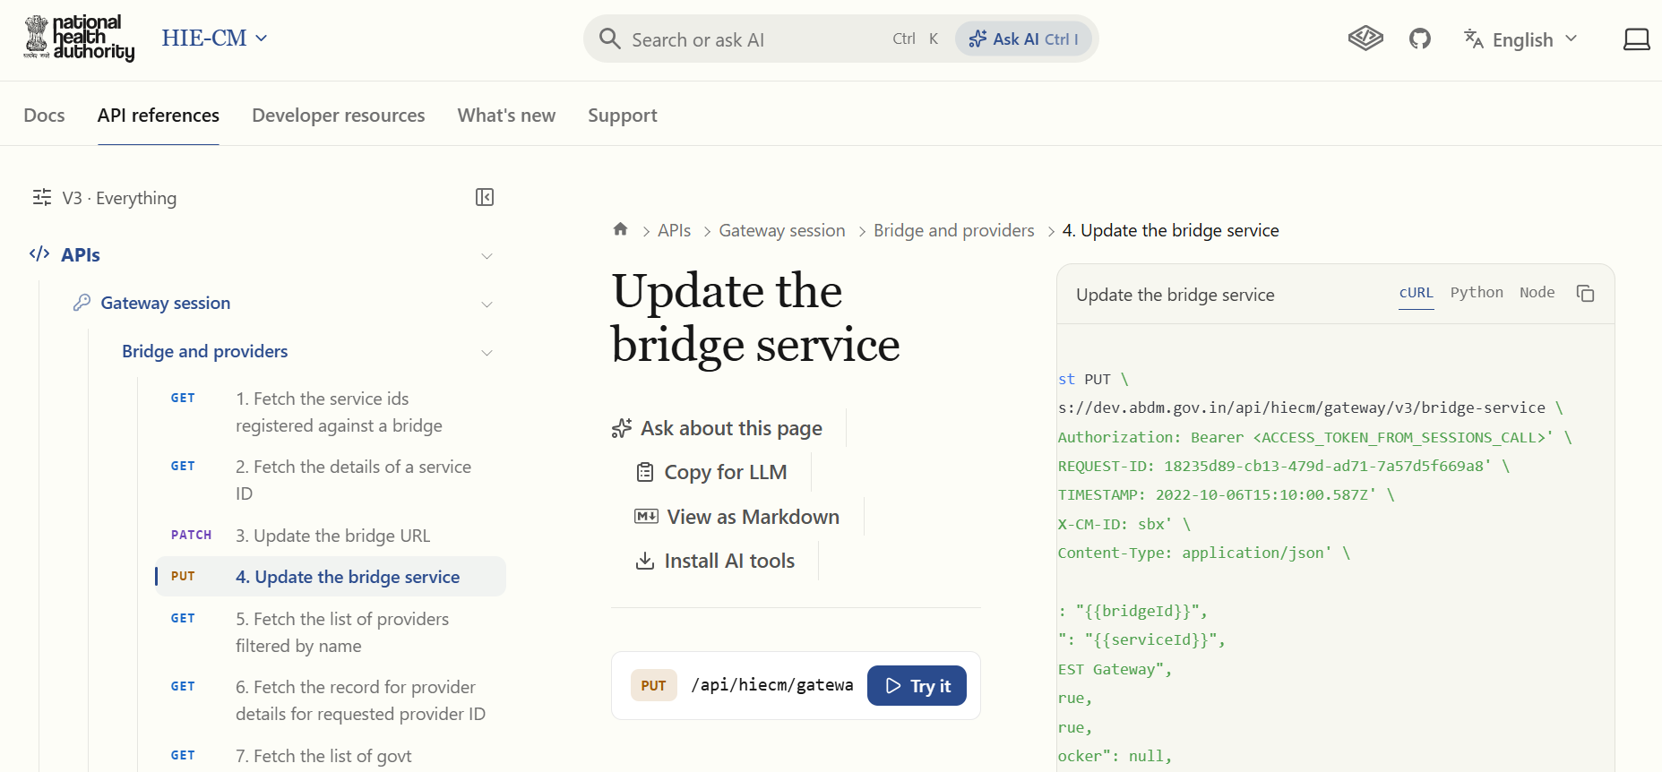

2. Keep only session API. Remove Open ID configuration APIs.
